**LAB : 5**

**OBJECTIVE :**

1. Draw a class diagram representing the relationship between parents and children. Take into account that a person can have both a parent and a child. Annotate associations with roles and multiplicities.
2. Draw a class diagram for bibliographic references. Use the references in Appendix C, Bibliography, to test your class diagram. Your class diagram should be as detailed as possible.

**Requrements :**

(a) Windows PC (Windows 7/8/10) / Mac

(b) Star UML Tool

**Procedure :**

1. Draw a class diagram representing the relationship between parents and children. Take into account that a person can have both a parent and a child. Annotate associations with roles and multiplicities.

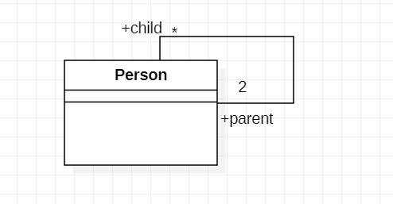

1. Draw a class diagram for bibliographic references. Use the references in Appendix C, Bibliography, to test your class diagram. Your class diagram should be as detailed as possible.

